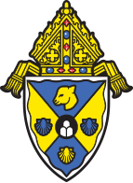
The Diocese of Rockville Centre

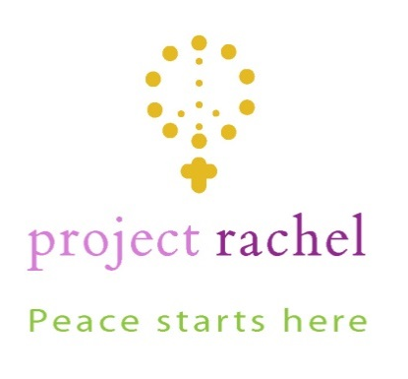

Healing after Abortion

Project Rachel retreats are opportunities to experience the loving mercy of God in a safe and sacred space. The retreats are directed by specially trained compassionate caregivers, including counselors and clergy, who have a sensitivity and heart for those who suffer.

Day or Prayer and Healing for Women

Saturday, April 25, 2020

Please register by April 20, 2020.

For more information please visit the Respect Life website respectlife.drvc.org or contact Project Rachel at projectrachel@drvc.org 1(888)456-HOPE (4673) 1(516)766-2538 (local phone number)

All information will remain confidential.

