**Maternity Advent Act of Kindness Project:**

**Please consider donating to help pregnant mothers in need.**

***Many of today’s young mothers face some of the same challenges as the Holy Family and are in need of shelter, basic amenities, love and prayer. Please support these young mothers’ choice for life!***

**If you would like more information, please visit** [**www.respectlife/drvc.org**](http://www.respectlife/drvc.org)

**To donate online, visit** [**www.respectlife.drvc.org/make-a-donation/**](http://www.respectlife.drvc.org/make-a-donation/)

*Our Advent project needs donations during the summer!*

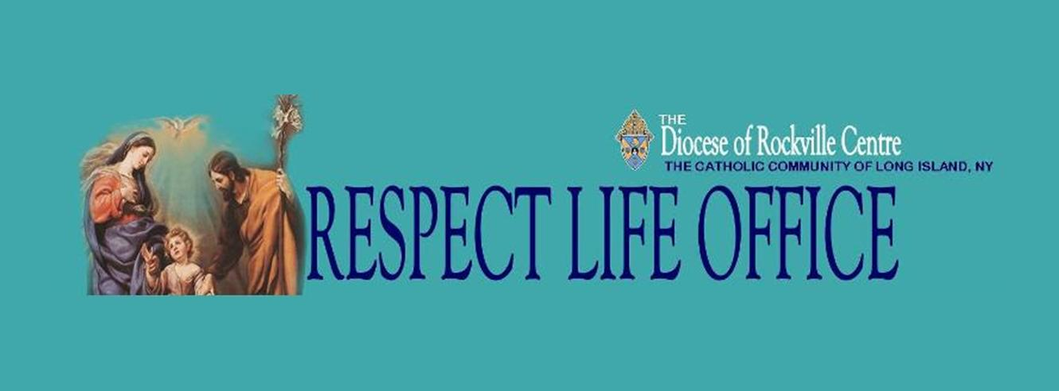

**Pregnant? In need of support?**

**Catholic Health Services and**

**Catholic Charities provide:**

* **Counseling**
* **Healthcare Access and**

**Navigation**

* **Housing**
* **And more…**

***Caring for mother and child with***

***compassion and dignity.***

**For more information, visit:**

[www.respectlife.drvc.org/crisis-pregnancy/](http://www.respectlife.drvc.org/crisis-pregnancy/)

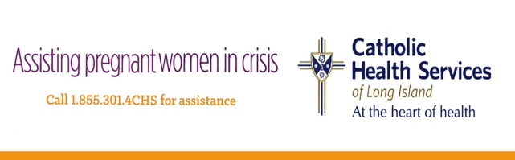

**Call 1.855.301.4CHS for help**

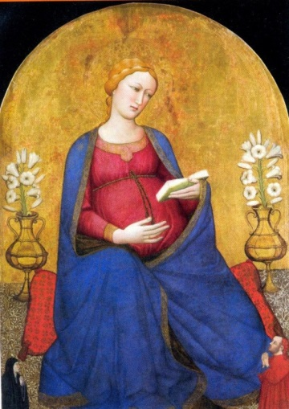

Our highly skilled team is delighted to offer an exciting approach to women’s health care. We provide preventive and specialized obstetrical and gynecologic care to women, honoring their dignity and the sanctity of human life.

Our Gianna Center of Long Island for Women’s Health & Fertility is located at **661 Deer Park Avenue, Babylon, NY 11702.**

For more information, call **(631) 376-3232** or visit www.chsli.org/gianna-center-long-island

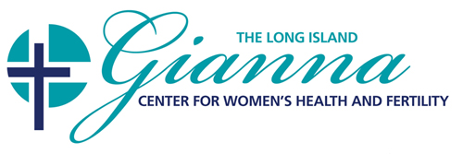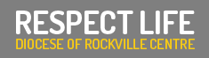

We all are God’s children, made in his image and likeness, and wherever life is threatened – violence, poverty, hunger, discrimination, abortion – God’s People defend it.

**The Diocese of Rockville Centre is pleased to announce the 2019 March for Life! It will be held in Washington, D.C. on Friday, January 18th.**

**For more information, visit** [**www.respectlife.drvc.org**](http://www.respectlife.drvc.org)

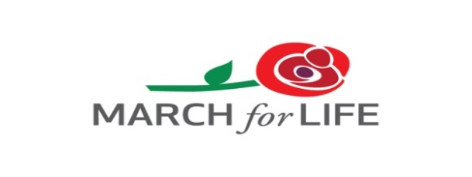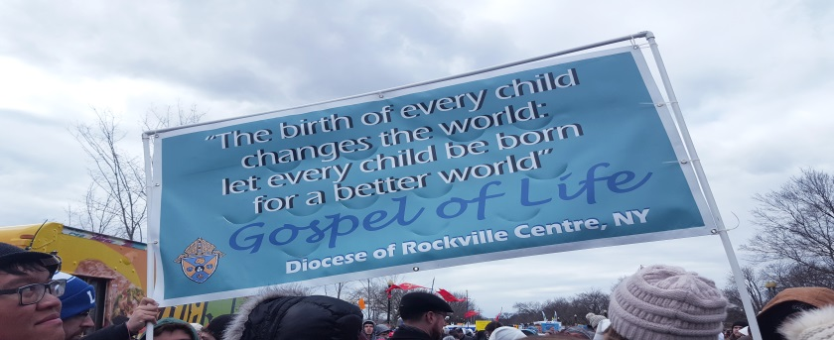

Healing After Abortion

*Project Rachel is an opportunity to experience*

*the loving mercy of God in a safe and sacred space.*

*Project Rachel is led by dedicated teams who have*

*a sensitivity and a heart for those who suffer.*

***For more information, please visit:***

[***www.respectlife.drvc.org***](http://www.respectlife.drvc.org)

***or call:***

***Project Rachel Local at (516) 766-2538***

*All information will be kept confidential.*

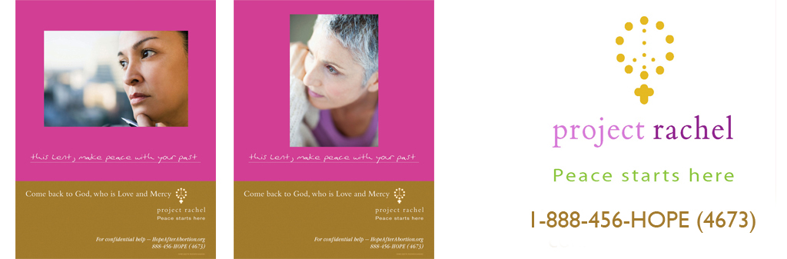

1-(888) 456-HOPE (4673)