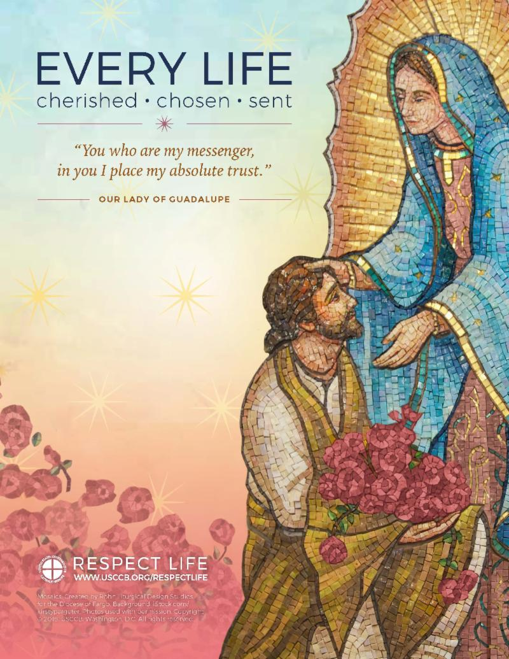

SAMPLE BULLETIN ANNOUNCEMENT

The Respect Life Office is excited to announce the
2018-19 Respect Life Youth Contest!
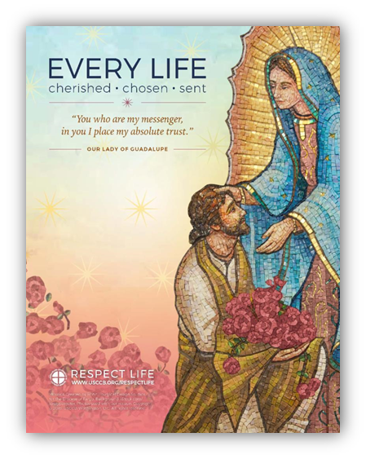

- Photography

- Video

- Mural for Life

- Poetry

- Bookmark Design

- Essay

- Music

♦Contest Theme ♦
EVERY LIFE
Cherished • Chosen• Sent

All Catholic youth in grades 7 through 12 who live in the Diocese of Rockville Centre and/or attend Catholic elementary schools, high schools or parish programs are invited to participate.

Winners will receive monetary awards in support of their future education!
1st place: $400 2nd place: $250 3rd place: $150

For further information contact your parish or school office.
Registration forms may be downloaded from the diocesan website: http://respectlife.drvc.org/

All parish/school winning entries must be submitted to the Diocesan Respect Life Office no later than January 25, 2019.

Diocese of Rockville Centre Respect Life Office | (516) 678-5800 Exts. 626 & 381

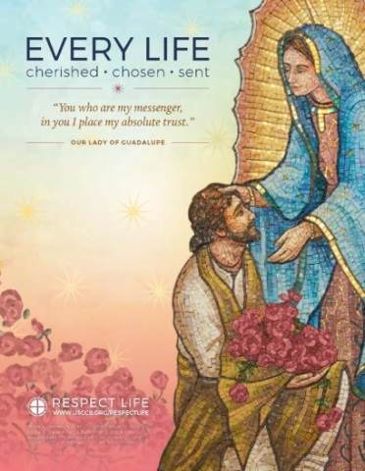
All Catholic youth in grades 7 through 12 who live in the Diocese of Rockville Centre and/or attend Catholic elementary schools, high schools or parish programs are invited to participate.

For further information visit: http://respectlife.drvc.org/

♦Contest Theme ♦
EVERY LIFE
Cherished • Chosen• Sent

The DRVC Respect Life Office is excited to
announce the 2019 Respect Life Youth Contest!

Poetry ♦ Bookmark Design ♦ Essay ♦ Music ♦ Photography
Video ♦ Interview ♦ Mural for Life

