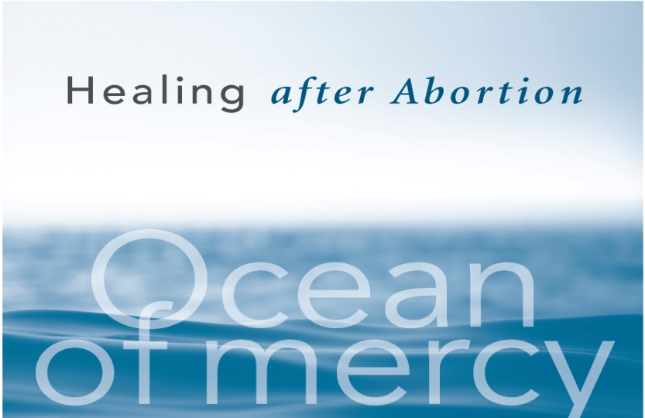
The Sisters of Life walk in solidarity with those suffering after abortion on the journey of healing.
The Sisters host monthly Days of Prayer and Healing, monthly Gatherings, and Hope and Healing Weekend Retreats. These events are opportunities to experience the loving mercy of God in a safe and sacred space.

All retreats are led by the Sisters of Life and women who have experienced both the suffering of abortion and the joy of healing in Christ. The retreats are directed by faithful priests who have a sensitivity and a heart for those who suffer. They include witnesses of mercy, Scripture sharing, personal prayer, opportunity for Sacramental Confession, and the Holy Sacrifice of the Mass.
Entering Canaan Days of Prayer and Healing for Women
(Developed by Theresa Bonopartis with the Sisters of Life)
Entering Canaan  DAYS OF PRAYER & HEALING  for Women | For more information or to register contact
Saturday, October 8, 2016  Saturday, October 22, 2016  (in Spanish)  Saturday, November 19, 2016  Saturday, December 10, 2016  (Long Island)  Saturday, January 14, 2017  Saturday, February 4, 2017  (in Spanish)  Saturday, March 18, 2017  Saturday, April 8, 2017  Saturday, May 20, 2017 | Sisters of Life at:  866.575.0075  (toll free) | hopeandhealing@sistersoflife.org  or Theresa Bonopartis:  877.586.4621  (toll free) | Lumina@postabortionhelp.org
Entering Canaan  DAYS OF PRAYER & HEALING  for Men  Saturday, October 29, 2016 | For more information or to register contact Lumina at:  877.586.4621  (toll free) | Lumina@postabortionhelp.org  postabortionhelp.org

