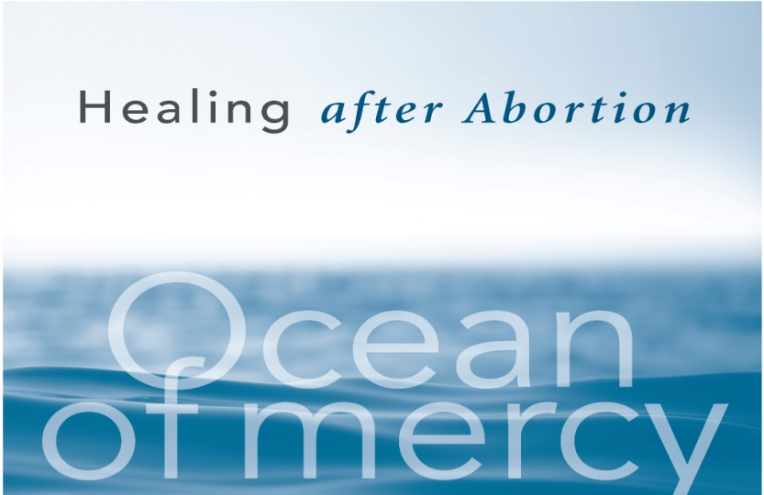

**Diocese of Rockville Centre**

**Day of Prayer and Healing**

**for Women**

The Day of Prayer and Healing for Women

is an opportunity to experience the loving

mercy of God in a safe and sacred space.

The day is directed by faithful priests

who have a sensitivity and a heart for those

who suffer.

**Sunday, March 5, 2017 Eastern Long Island Location**

**For more information visit:** respectlife.drvc.org

**To register contact:** Project Rachel

1-888-456-4673 | [projectrachel@drvc.org](mailto:projectrachel@drvc.org)

*All reservations and information will remain confidential.*